QUESTIONS AND ANSWERS

Answers to many commonly asked questions about P-EBT food benefits for Illinois residents:

What are P-EBT food benefits?
The Pandemic Electronic Benefit Transfer (P-EBT) provides benefits to certain children who receive free or reduced-price school lunches under the National School Lunch Act. P-EBT is a temporary food benefit program operating during the COVID-19 pandemic. P-EBT only provides benefits for days that students lack access to an in-school lunch. P-EBT provides $6.82 per each school day that children are engaged in remote learning.

Who is eligible for P-EBT benefits?
Your child and your school must meet certain criteria to be eligible for P-EBT:

Your Child:
- Must be enrolled in free or reduced-price school meals at a school operating the National School Lunch Program; OR,
- Must be enrolled in a Community Eligibility Provision (CEP) or Provision-2 school, which offers breakfast and lunch free to all students; AND,
- Must have not had access to an in-school lunch at least some days of the month

Your School:
- Must operate the National School Lunch Program; AND,
- Must have been closed or operating at reduced capacity at least 5 consecutive days at some point during the 2020-2021 School Year.

How are P-EBT benefits issued? Do I need to apply?
If your child is already enrolled in free or reduced-price school meals AND your address is up-to-date:
- Your family will get P-EBT automatically. Each child will receive their own card.
- Cards will be mailed to you in March.
- Cards will arrive in an unmarked envelope so please be on the lookout.
- Families should hold onto their P-EBT card(s) because future benefits will be loaded onto the same card.

If you are new to a school district, if your child did not receive free or reduced-price meals last school year, OR if you recently moved:
- You must fill out an application for free or reduced-price school meals by contacting your school.
- You must make sure your school has your correct address.

What if I don’t have a home address? Can I still apply
If you are homeless or don’t have a regular address where you can receive mail, you can use your school’s address. Families should talk with their school’s homeless liaison coordinator to assist them. The child’s P-EBT card will be mailed to the school where the family can pick it up.

When will P-EBT benefits be issued?
Benefits will be issued for August 2020 through June 2021 for the days that student haven’t had access to in-person lunch during the 2020-2021 school year.
- In March, families will receive a distribution for the months of August 2020 through December 2020.
- In April, families will receive a distribution for January 2021 through February.
- Beginning in May, families will receive a monthly benefit for the remainder of the school year.

Benefits will be issued between the 11th and the 22nd of each month going by the first letter of the student’s last name. Students’ benefits will be issued on the same day in subsequent months so your family can plan your food budget.

When I get my child’s P-EBT card, do I need to activate it?
Yes, you will need to activate the P-EBT card by calling the phone number on the card. When you activate the card, it will ask for social security number, date of birth, and PIN.

- When prompted for social security number, you should use the number 9 for the entire social security number. For example, it will look like this for the social security number: 999-99-9999
- For date of birth, you must enter your child’s birthday.
- You will choose a PIN for the card. When you go shopping, you will enter this PIN in order to make a purchase with the card.

I am worried about receiving P-EBT because of my immigration status. Will getting this benefit count in a public charge test?
No. It is important to know that P-EBT will not count in a public charge test. All students are eligible regardless of immigration status. Visit ProtectingImmigrantFamilies.Org for information about what public benefits impact the public charge test.

I have been receiving grab ‘n go meals at my school. Can I still receive P-EBT?
Yes, children and teens can still receive free meals from school and community sites AND get P-EBT, too – they are separate programs.
- To find free meal sites near you, text the word “food” or “comida” to “877-877”
- You can also visit your school district website to find school meal locations in your area.

In the 2019-2020 school year I had to apply for P-EBT benefits. Do I need to fill out another application?
You do not need to apply for P-EBT, but you must make sure your child is enrolled in free or reduced-price meals OR attends a CEP school where all meals are provided for free AND that your address is up-to-date with your school.

In the 2019-2020 school year I received P-EBT benefits. Will the benefits for the 2020-2021 school year be loaded onto the same P-EBT card?

No, you will receive a new P-EBT card with the student’s name on the card. Each month, benefits will automatically be loaded onto that card for as long as P-EBT operates.

In the 2019-2020 I received P-EBT benefits but I threw away or lost my P-EBT card. Can I still get benefits?

Yes, you will receive a new P-EBT card with the student’s name on the card. Each month, benefits will automatically be loaded onto that card for as long as P-EBT operates. P-EBT cards from last year will not work anymore, you need to receive a new P-EBT card.

If I’m currently receiving LINK, can P-EBT benefits be loaded on to there?

No, you will receive a new EBT card with the student’s name on the card specifically for P-EBT. Each month, benefits will automatically be loaded onto that card for as long as P-EBT operates.

My child is attending school in the classroom every day. Are they eligible for P-EBT?
P-EBT benefits are supposed to replace the meals that students receive in person at the school. A student who is in the classroom full-time will receive meals at the school instead of receiving a P-EBT benefit. If they have an excused absence related to COVID-19, they can receive P-EBT for those days.

My child is attending school in a hybrid model where they are in the classroom some days and learning remote some days. Are they eligible for P-EBT?
Yes, your child’s attendance will be counted by the school and they will receive a benefit amount based on the number of days that they lack access to an in-school lunch.

I think my child is eligible for free or reduced-price meals but we haven’t enrolled. Can I still get P-EBT?
You can still get P-EBT but you must apply for free or reduced-price meals with your child’s school. You may be eligible for benefits retroactive to August but you should apply as soon as possible.
How do I know if my child is eligible for free or reduced-price lunch?
The table below show the income guidelines for free and reduced-price lunches. Visit https://www.isbe.net/Documents/IEG-21.pdf for more information.
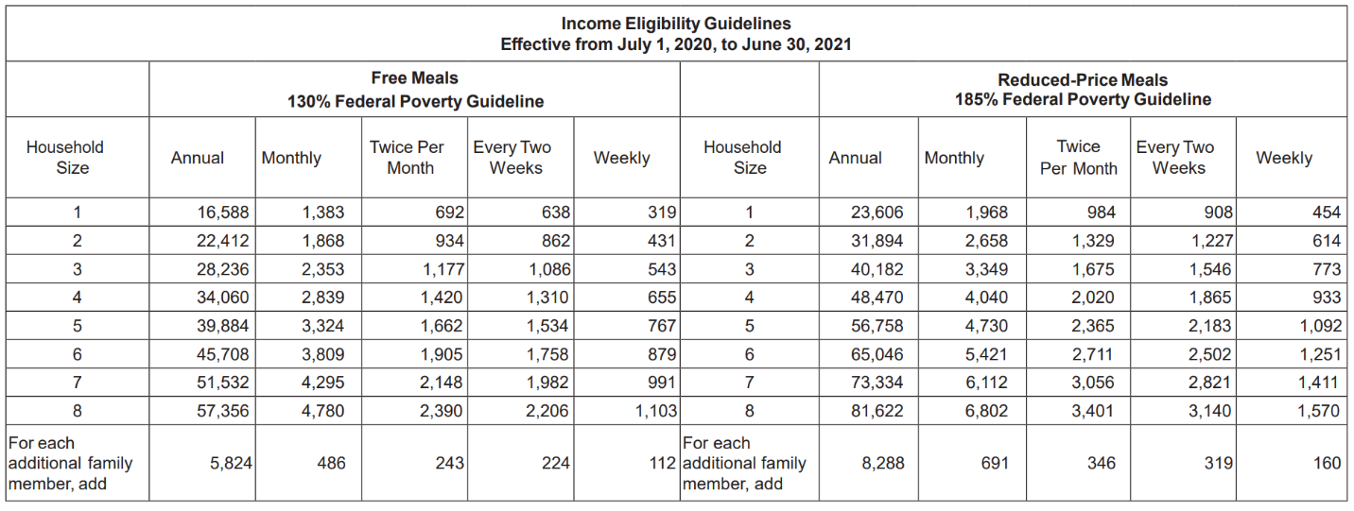

My child received free or reduced-price school meals, but I did not receive a P-EBT card in the mail. Who do I contact?
Benefit cards will not be mailed until March. If it is February or March, please be patient as the state implements this new program. If it is the end of March and you have not received your card please call the Illinois Department of Human Services at 1-800-843-6154 or email DHS.FCS.PEBT@illinois.gov.

My child didn’t get P-EBT in the 2019-2020 school year. Can I apply now and still get P-EBT benefits for the 2019-2020 school year?
No, you cannot get P-EBT benefits for the 2019-2020 school year. However, you may be eligible to receive benefits retroactively to the start of this school year (August 2020) if your child was engaged in remote learning.

If my child receives P-EBT, can I still get food pantry benefits?
Yes, your participation in government programs does not affect your ability to get food from a food pantry.

Where can I redeem P-EBT benefits?
P-EBT benefits are provided on a card that can be used like a debit card to purchase food at SNAP/LINK authorized grocery stores.

